PROSEDUR KENDALI DOKUMEN | LSG-05.03
SURAT PERMINTAAN BARANG | HO/SH | THN
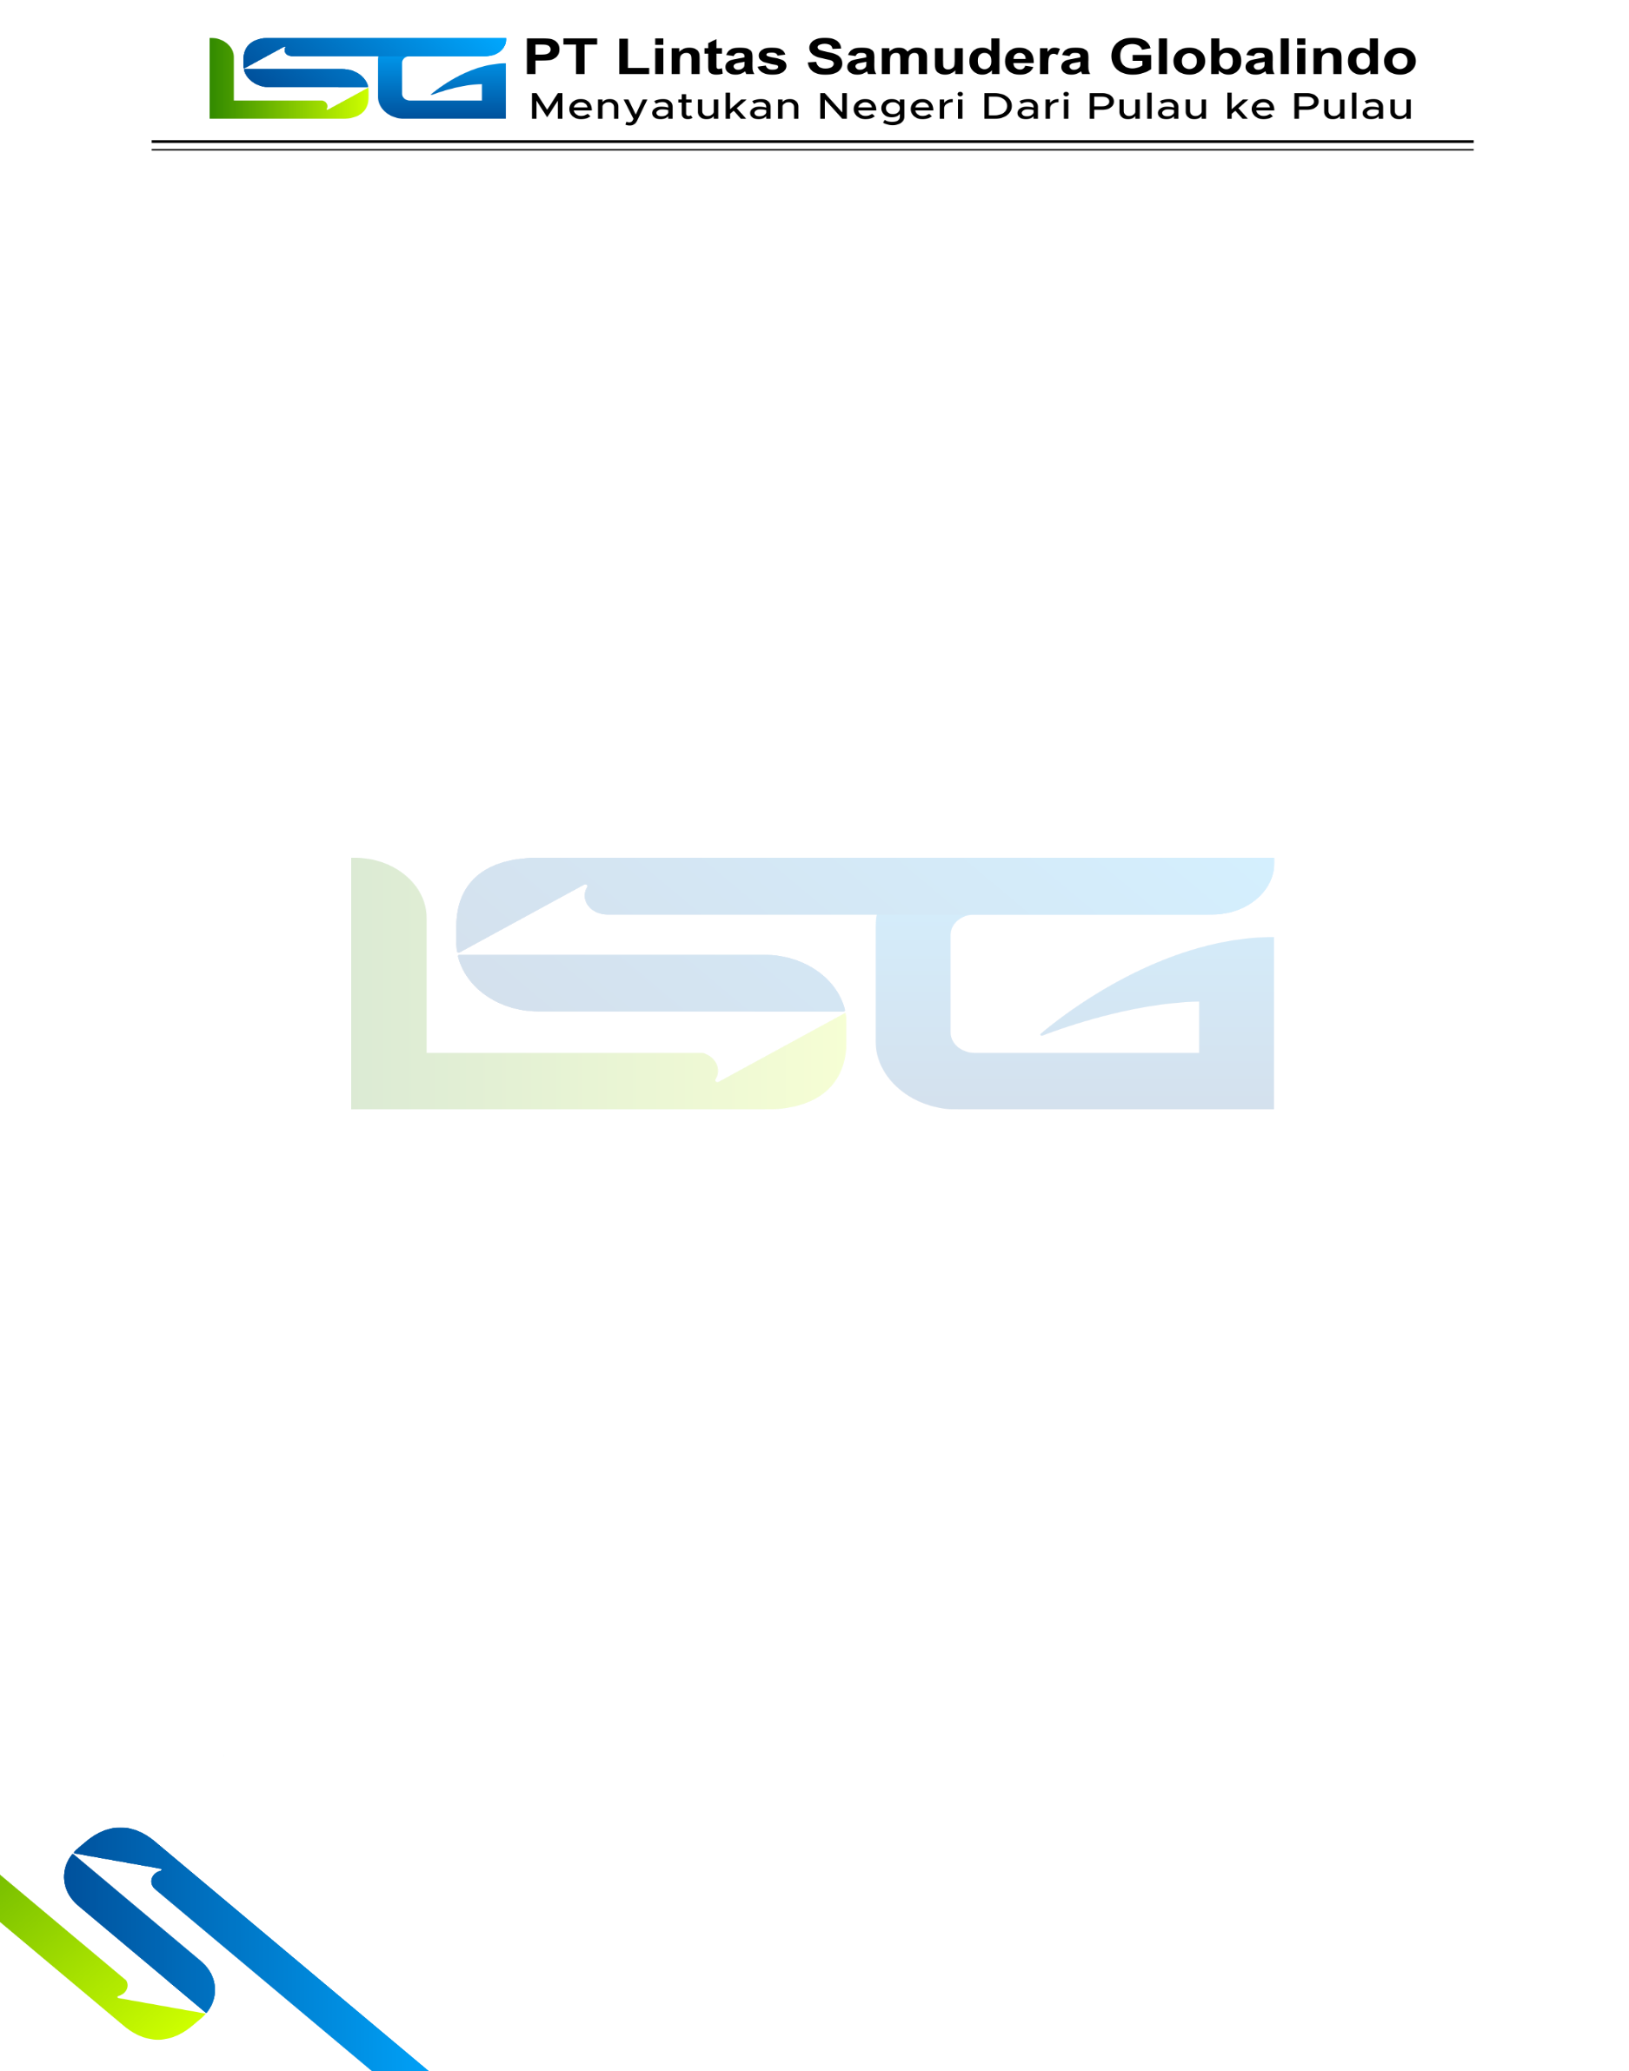

Nama Kapal : KM.KENDHAGA NUSANTARA 5
Tanggal : 03 AGUSTUS 2026
Bagian : Mesin

NO. | NAMA BARANG | QTY | HARGA | TGL/TERAKIR RENEW | CODE BARANG | KETERANGAN | FOTO
1 | ACCU | 2 PCS |  |  | N150 YUASSA | PERGANTIAN BARU | 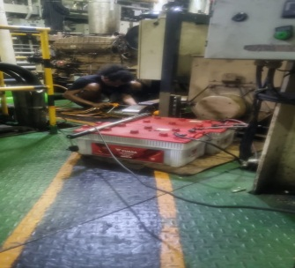
2 | KUNCI PLONG GASKET | 1 SET |  |  | WIPRO | PENGADAAN BARU | 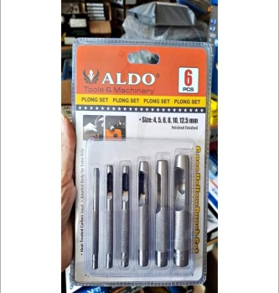
3 | TANG BUAYA | 1 PCS |  |  | WIPRO | PENGADAAN BARU | 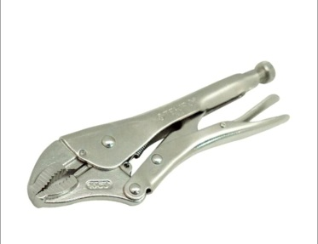
4 | KRAN BUTTERFLY 5” | 3 PCS |  |  |  | RUSAK | 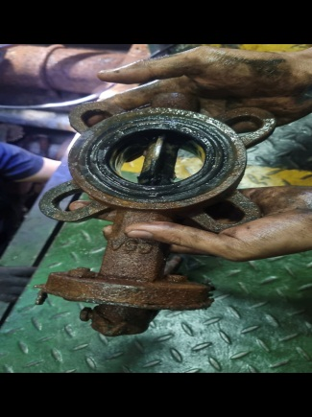
5 | OLI SAE 40 | 4 DRUM |  | 11 JULI 2026 | PERTAMINA | HABIS | 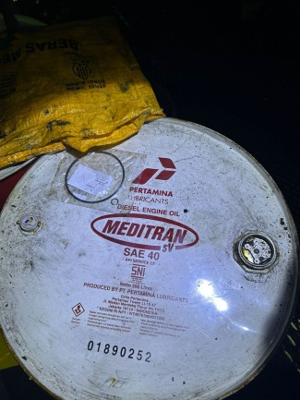
6 | AIR ACCU | 3 DUS |  | 11 JULI 2026 | YUASSA | 10 LITER | 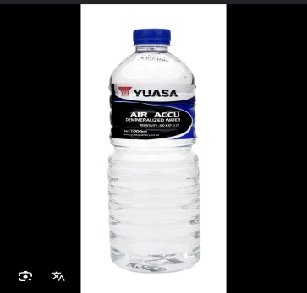
7 | PACKING KARET 5MM | 1 ROLL |  |  |  | HABIS | 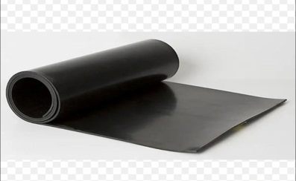
8 | LEM GASKET | 5 PCS |  |  | INDIAN GASKET |  | 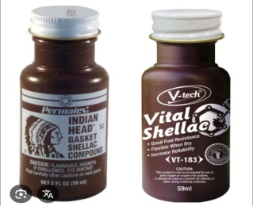
9 | CLAM 2” DAN 1 “ | 5 PCS |  |  |  | HABIS | 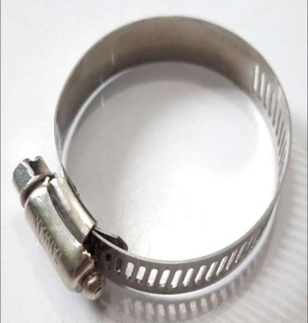
10 | AVR MX341 E000-23412 | 3 PCS |  |  | MX341 ( E000-23412 ) | RUSAK | 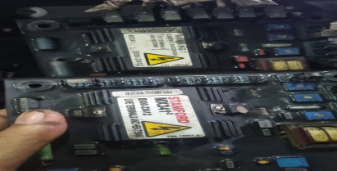
11 | FILTER WINCH | 4 PCS |  |  | MF4002P25NBP01 | HABIS | 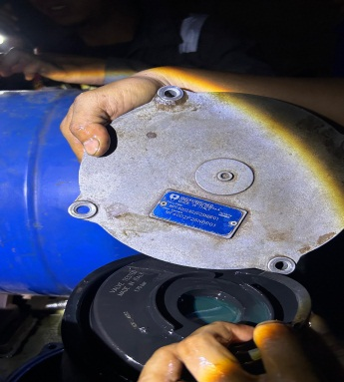
12 | FILTER STERRING GEAR | 4 PCS |  |  | MF1801P25NBP01 | HABIS
13 | SELENOID VT PUMP AE | 1 PCS |  |  | 3035346 (CUMINS NTA -855) | PERGANTIAN BARU | 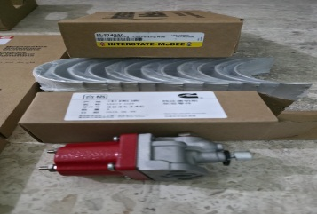
14 | FILTER OLI ME | 12 PCS |  |  | DONALDSON J8610431 | HABIS | 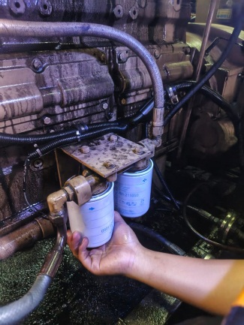
15 | FILTER BBM ME | 20 PCS |  | 11 JULI 2026 | DONALDSON J8621105D | HABIS
16 | FILTER RACKOR BBM AE | 10 PCS |  | 11 JULI 2026 | SF 7901 | HABIS
17 | OLI SAE10 | 1 DRUM |  |  | PERTAMINA | HABIS | 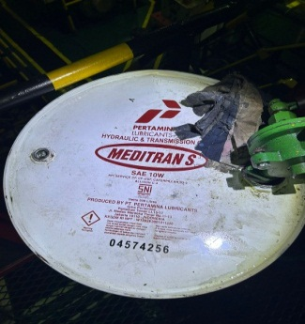
18 | THREEBOND GREY HIGH TEMP | 4 PCS |  |  | THREEBOND | TIDAK ADA | 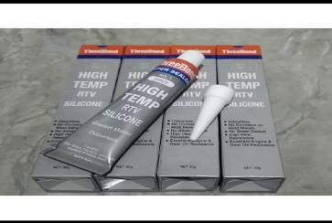
19 | FULLER GAUGE | 1 SET |  |  | WIPRO | RUSAK | 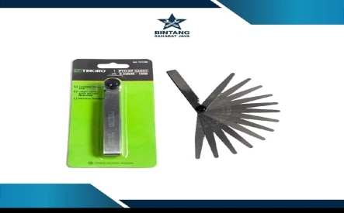
20 | WD - 40 | 2 PCS |  |  | WD-40 | HABIS | 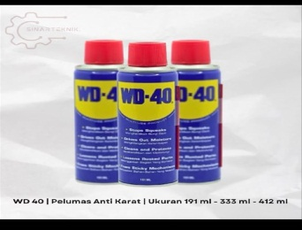
21 | SOLASI KERTAS | 4 PCS |  |  |  | HABIS | 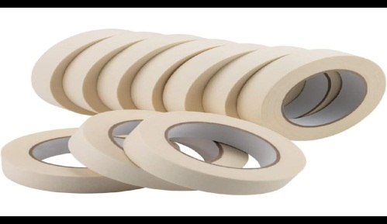
22 | DETERGEN | 2 DUS |  |  |  | HABIS | 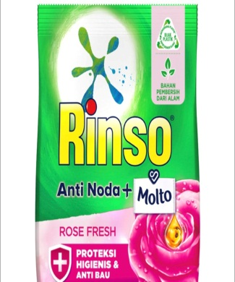
23 | LEM BESI | 5 PCS |  |  | DEXTON | HABIS | 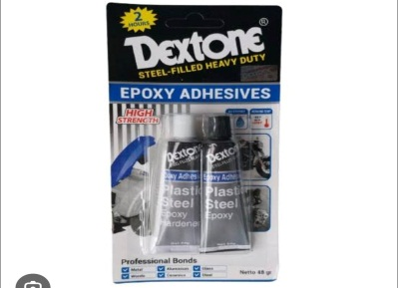
24 | PRESSURE GAUGE 0-60 Mpa | 1 PCS |  |  |  | WIPRO | 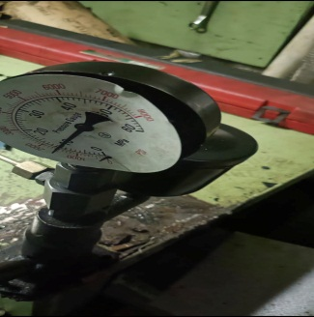
25 | MAJUN | 50 KG |  |  |  | HABIS | 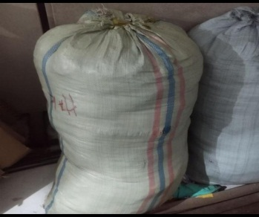

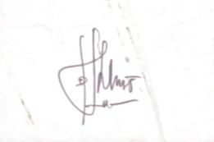
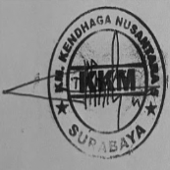
Mengetahui, Membuat,

_________ _ ___________ KKM Masinis I

Mengetahui, Mengetahui, Menyetujui,

_________ _ ___________ ___________
Port Engine Logistik Manager Armada

